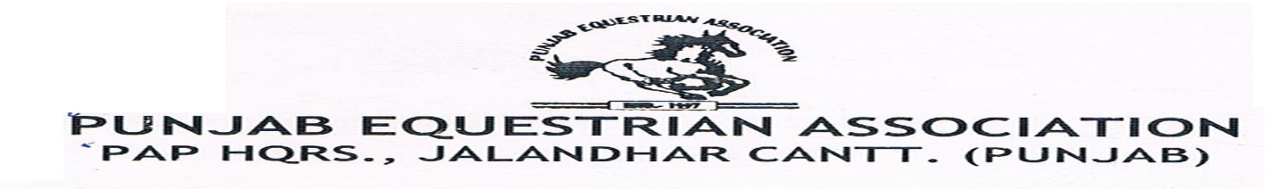
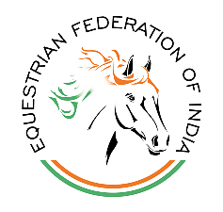

REGIONAL EQUESTRIAN LEAGUE (REL) TENT PEGING

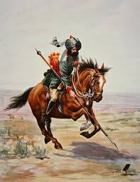

On 25 October 2018

AT

Equestrian Grounds, Punjab Armed Police (PAPHQ )
Jalandhar Cantt. Punjab

Organized by
7th Battalion Punjab Armed Police Jalandhar

REGIONAL EQUESTRIAN LEAGUE (REL) TENT PEGING
Introduction

The 7th Battalion PAP Jalandhar Cantt is hosting Regional Equestrian League (REL) on 25 October 2018 according of the rules of the Equestrian Federation of India, as per the attached schedule of events Appendix I, at the Punjab Armed Police HQ Jalandhar. All or any information related to the prospectus, schedule of events or other details can be received by communicating via E-mail: inchargemap@gmail.com or contacting the following officials of the 7th Battalion PAP Jalandhar Cantt.
The details of the officers to be contacted for assistance or information are given below:-

Name & Designation | Phone No./Fax No. | E-mail
ShHarkamalPreet Singh Khakh, PPS  Commandant, 7th Battalion  PAP Jalandhar Cantt  Organizing Secretary | 0181-2455574
InspTalwinder Singh  Asstt. Organizing Secretary | 98148-15787 | inchargemap@gmail.com
Sub InspYoungbir Singh  Show Secretary | 97799-09002 | youngbirsingh@gmail.com
Sub Insp Ram Lal  Camp Incharge | 94648-89510 | inchargemap@gmail.com

- VENUE: The Regional Equestrian League (REL)will be held at the Punjab Armed Police Campus, Jalandhar Cantt, on 25 Oct 2018 as per EFI guidelines for REL & Tent Pegging Event
- ENTRIES:
- Entry fee for REL will be Rs. 500 per exhibit.
- All Entries will be made on the entry form attached as Appendix II and will be as per the E.F.I technical guidelines.
- No entry will be accepted without an entry fee.
- Payment: All entries must be made to the Show Secretary at the show office.
- No entry will be accepted after the Draw of Lots.
- No entry fees will be refunded once deposit.

- CLOSING DATE FOR RECEIPT OF ENTRIES:
All Entries must be submitted on or before 24 October 2018 (05.00 PM)
Note:- After the closing date all entries will be accepted as POST ENTRIES, which will be double of the normal entry for the particular event.
- ELIGIBILITY for the RIDER:-
- To participate in the NEC Tent Pegging, Rider’s EFI ID No. is mandatory.
- Other eligibility for riders will be as per FEI/EFI Technical guidelines for Tent Pegging event.
- REGISTRATION OF HORSES:-
All Horses participating in the Regional Equestrian League (REL) must be registered with EFI and registration No. allotted by EFI must be tie on bridle of horse, during participation and when the horse moves out of the stables/camping area during stay at Championship. No horse is allowed to participate without EFI horse registration.

- CAMP
i) The camp will be located adjacent to the Equestrian Grounds. The Camp In-charge will earmark the site for each contingent. The Camp will become operational on 24 Oct 2018 and will be closed on 25 Oct 2018.
ii) Horses, riders, grooms/farriers coming to participate in National Tent Pegging Championship- 2016 will stay in the camping area. No team will be allowed to enter the camping area before 24 Oct 2018.
iii) Advance information about the number of participants/ horses must be conveyed to the organizers by 20 Oct 2018 so as to finalize camping arrangements.
- SELF CONTAINMENT:
All teams coming to participate in the Regional Equestrian League (REL)must be self- contained, i.e. they should bring their own equipment, tent, feed, fodder, cooks, farriers and transport etc.
- CLIMATE:
The climate in the month of October is pleasant. Participants are advised to make requisite arrangements.
- LIGHTING:
The participants are requested to bring their own Hurricane Lanterns/ Petromax Lamps for emergency use. Power / light will be provided under camp arrangements where feasible.
- DISCIPLINE:
All the participants staying in the camp will be under the camp in-charge for the purpose of discipline.
- FIRE PRECAUTIONS:
All the participants are required to undertake fire-fighting precaution in their respective areas.
- SANITATION AND HYGEINE:
All participants should observe proper sanitation and hygienic measures. There should be proper disposal of litter at pre designated location.
- MEDICAL ASSISTANCE:
Medical assistance will be provided at the camp site and competition area.
- VETERINARY ASSISTANCE:
Veterinary assistance will be available at the Camp site and competition area.
- RESPONSIBILITY:
The organizing committee accepts no responsibility for any injury or loss to entrant/competitor
through accident or any other cause. Neither the organizers nor the vet / medico will be held responsible for the consequences of the first aid or other medical treatment given to any injured horse or rider.
- DRESS CODE:
Riders Dress Code & tack of horse will be as per FEI/EFI Guidelines.
- COGGIN’s & MALLEIN TEST:
All participating horses must a possess a negative Coggins&Glanders (CFT) Test Report . No horse will be allowed inside the camping area without valid Coggins&Mallein(CFT)test reports.
- SPECTATORS/OUTSIDE ASSISTENCE:
The spectators or the supporters of the participants are not to interfere with the Judges. The Arena Steward has the right to eliminate any participant who has outside help.Once the event has commenced, all spectators and helpers are to clear the arena.The Judges’ decision will be final. Parents must not enter the arena or dispute the decision or confront the Judges.
- VETERINARY INSPECTION:
All participants for the Regional Equestrian League (REL) are required to present their horses for veterinary Inspection (Trotting Parade) on 24 Oct 2018 in the competition grounds along with a copy of the Coggins&Glanders (CFT) Test report and EFI passports of the horses.
- CONDUCT RULES:
- The events will be conducted & adjudged as per rules of EFI ( Equestrian Federation of India)
- The events are judged by the panel of judges who are experts in the field of equestrian sports.
- The decision of the jury will be final.

- OBJECTIONS:
a) Objections may only be lodged by owner or person responsible for horses taking part in the event.
b) The objections must be lodged within half an hour of the result announced.
c) A deposit of Rs 2000/- must accompany all objections in regard to any matter during the REL.

- MISCELLANEOUS:

a) Any questions arise not provided for, it must be referred to the Jury, whose decisions will be final.
b) Scheduling time and entries are subject to alteration at the discretion of the organizing committee.

Appendix-I
Regional Equestrian League (REL)
TENTATIVE SCHEDULE
24 Oct 2018

Veterinary Inspection 05.00 PM
Draw of Lots 06.00 P.M

25 Oct 2018
S r No. | EVENT | TIME | VENUE
1. | REL Tent Pegging with Lance (Round A) | 8.00 AM | Tent Pegging Track
2. | REL Tent Pegging with Sword (Round B) | 11.00 AM | Tent Pegging Track

Appendix-II

Entry Form
Regional Equestrian League (REL)
Name of Team/Club/State:______________

Sr. No. | Name of Event | Name of Rider | Rider ID No. | Exhibitor |  |  |  |  | Entry Fee
 |  |  |  | Name of Horse | Color | Sex | Age | EFI No. | Entry Fee

Signature

